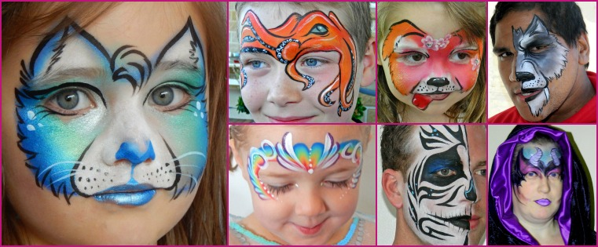
BOOKING FORM (Private)

FULL NAME: Click here to enter text.
MOBILE PH: Click here to enter text.
EMAIL: Click here to enter text.
ADDRESS OF EVENT: Click here to enter text.
TYPE OF EVENT: Click here to enter text.
DATE: Click here to enter text.
TIME REQUIRED: 1hr ☐
1.5hrs ☐
2hrs ☐
2.5hrs ☐
3hrs ☐

START TIME: Click here to enter text.
FINISH TIME: Click here to enter text.

GUEST OF HONOUR
AND AGE: Click here to enter text.

INTERESTS (Favourite colours, characters etc): Click here to enter text.
NUMBER OF GUESTS: Click here to enter text.
SERVICES REQUIRED: Choose an item.
NUMBER OF ARTISTS: Click here to enter text.
ADDITIONAL COSTS: Travel ☐
Photo Package ☐
Parking ☐

ALTERNATIVE LOCATION: Click here to enter text.

HOW DID YOU HEAR
ABOUT US: Click here to enter text.

The Booking Fee is a part-payment of the total cost that confirms and holds your chosen date and time.
Once the Booking Form and Fee are received, Face Your Fantasy will reserve the date and time agreed upon, and will not make any other reservations or accept any other clients for the said date and time. For this reason, in the event that you, the client, cancel the booking for any reason less than 14 days prior to the agreed date and time, the Booking fee will be retained by Face Your Fantasy to offset business losses. If I am not notified of cancellation and arrive at the event FULL PAYMENT IS REQUIRED.
IMPORTANT: Please do NOT pay the Booking Fee until I confirm with you that I am available for the date and time you wish to book.
The remaining balance must be PAID IN FULL, ON ARRIVAL, and BEFORE THE START OF THE EVENT.
Cheques are NOT accepted.

BY SENDING THIS COMPLETED BOOKING FORM YOU ARE AGREEING THAT YOU HAVE READ, UNDERSTOOD AND ACCEPT THE TERMS AND CONDITIONS AS STATED IN THIS AGREEMENT.

TERMS AND CONDITIONS

The outstanding balance must be paid in full ON ARRIVAL before the event starts.
I will arrive approximately 15 to 20 mins early to set up in order to start at the booked time.
The time booked is the length of time required to service the number of guests specified by the client. In order to ensure all guests receive their face paint/balloon, the artist must continue to work throughout the scheduled time. If the client wishes to break for cake cutting, games etc, additional time needs to be booked.
The artist is not responsible for the late arrival of guests.
Full payment is required in the event that the expected number of guests do not show up or use the Artists services.
Although every effort is made to ensure I reach you on time, if the Artist is unable to carry out your event due to unforeseen circumstances beyond my control, severe weather conditions or traffic/accidents, your booking fee will be returned in full. In cases such as illness etc. all efforts will be made to secure a replacement face painter. If I am unable to do so your booking fee will be returned in full.
Children must be supervised at all times by a responsible adult.
I paint the faces of those 3 years and over with clean faces who wish to be painted.
I DO NOT paint those look sick - with runny noses/sneezing/coughing, conjunctivitis (red/watery/crusty eyes), sores around the mouth, skin conditions (acne, eczema etc.), cuts or abrasions.
I do not make balloons for under 4’s as they are a choking hazard. Children 4 to 8 years with balloons must be supervised. Balloons are made from natural latex and may cause an allergic reaction.
I require parking close to the venue.
I require a fully sheltered area, completely out of the elements (direct sun, wind etc.) In the event of inclement weather (including rain, wind, extreme temperatures), the client will provide an alternate indoor location. If there are adverse working conditions such as unsuitable shelter, inclement weather, inappropriate behaviour, illegal activities etc. that are brought to the attention of the Client and are not rectified, I reserve the right to leave the event without refunding payment.
I reserve the right to refuse service of anyone drunk, abusive or otherwise displaying unsocial, inappropriate or aggressive behaviour, be they adults or children.
I carry Public Liability Insurance and a current Working with Children check.
I use cosmetic grade, professional products and whilst every care is taken, those with sensitive skin or allergies should not participate, or should have the Artist perform a patch test at least 15mins before being painted.
While the Artist will take every care, we will not be responsible for damage to clothing or property. The client agrees to pay for any accidents or injuries caused by pets or guests and/or damage to the Artists equipment or supplies caused by pets or guests. The behaviour of pets and guests is the responsibility of the Client or Parent.

Please save form and email to faceyourfantasy@gmail.com
Thank you.

